AWS Get IT Programme Future Foundations (FF) Joining Instructions
DATES:
The Bootcamp details:
The 2019 Manchester date is:
- Wednesday 6th November
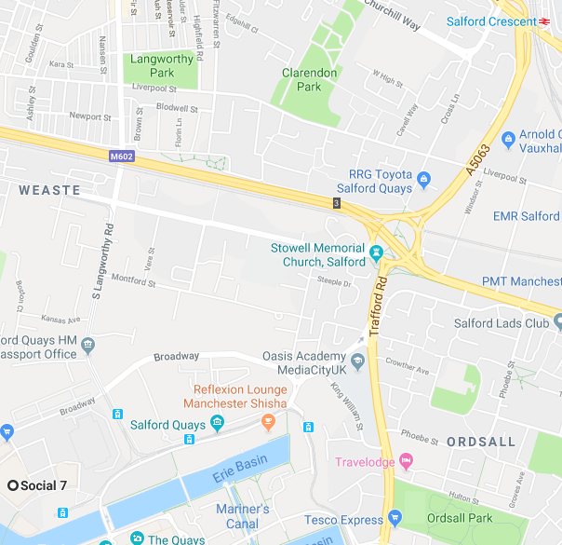
LOCATION:
The Bootcamp will be held at the venue below.
The full address is:
Social 7
7th Floor,
The Landing, Blue Tower,
MediaCityUK.
Salford
M50 2ST

GETTING THERE:

The nearest station is Salford Crescent Station which services the tram system direct to Manchester Piccadilly trains station and the CityConnet 50 bus service.

ON THE DAY:
9 – 9.45am: Registration
10am – 4pm: Bootcamp

Please register for the day between 9 and 9.45am in the foyer. FF staff and the AWS ambassadors will be there to greet you, help you register and show to you to the space.

Lunch and refreshments will be provided. However feel free to bring snacks as it will be a jammed packed day, so lots of energy will be needed!

Please ensure you alert us to any dietary requirements you and your students have on your registration form.

WHAT TO BRING:

- The students will be given an AWS Get IT T-shirt, so they should perhaps wear a long sleeved top suitable to wear the T-shirt over
- It’s up to you if the students wear uniform or their own clothes
- A water bottle – there will be fill up stations at AWS
- Any snacks to keep them going!
- Writing pens and colouring pens
- Project packs and any scrapbook
- Other material built so far
- Thinking hats, open minds and big ideas!

From competition side – everything you need to have done and completed by the bootcamp is in the Challenge Pack.

All the information for the bootcamps is also on our website: https://www.future-foundations.co.uk/awsgetit-bootcamp/.

If you have any questions, please email Emily on emily.clark@future-foundations.co.uk

