AWS Get IT Programme Future Foundations (FF) Joining Instructions
DATES:
The Bootcamps are on four separate dates: Your school should have been allocated one of the dates below.
The 2019 dates are:
- Tuesday 8th October
- Thursday 10th October
- Wednesday 16th October
- Tuesday 19th November
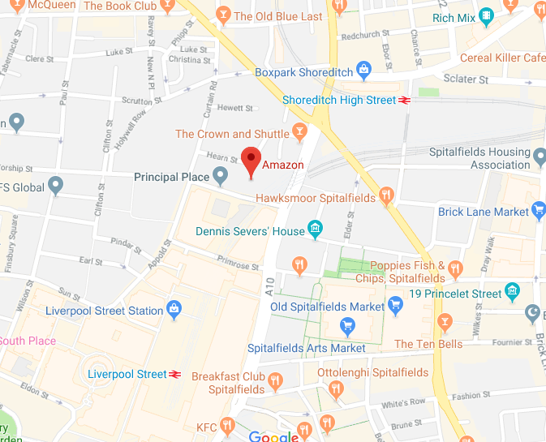
LOCATION:
All four Bootcamps will be held at the Shoreditch offices of Amazon Web Services.
The full address is:
AWS
1 Principal Place
Worship St
London
EC2A 2BA

Please note there is also an office in Holborn – this isn’t the venue!

GETTING THERE:

The nearest station is Shoreditch High Street and it’s a short walk from there. Although the offices are on Worship Street the main entrance faces Shoreditch High Street. Shoreditch High Street is serviced by numerous buses.

ON THE DAY:
9 – 9.45am: Registration
10am – 4pm: Bootcamp

Please register for the day between 9 and 9.45am in the AWS foyer. FF staff and the AWS ambassadors will be there to greet you, help you register and show to you to the space.

Lunch and refreshments will be provided. However feel free to bring snacks as it will be a jammed packed day, so lots of energy will be needed!

Please ensure you alert us to any dietary requirements you and your students have on your registration form.

WHAT TO BRING:

- The students will be given an AWS Get IT T-shirt, so they should perhaps wear a long sleeved top suitable to wear the T-shirt over
- It’s up to you if the students wear uniform or their own clothes
- A water bottle – there will be fill up stations at AWS
- Any snacks to keep them going!
- Writing pens and colouring pens
- Project packs and any scrapbook
- Other material built so far
- Thinking hats, open minds and big ideas!

From competition side – everything you need to have done and completed by the bootcamp is in the Challenge Pack.

All the information for the bootcamps is also on our website: https://www.future-foundations.co.uk/awsgetit-bootcamp/.

If you have any questions, please email Emily on emily.clark@future-foundations.co.uk

