For any serious accidents or incidents always call 999.
You can also contact the on-site security team on 07484 518 179.
If you discover a fire
- Sound the alarm by using a red fire call point
- Leave the building by the nearest available exit
- Report to the assembly point: Elder Gardens, Off Folgate Street
Upon hearing the alarm
- Upon hearing the address system to leave: do so immediately by the nearest exit and make your way to: Elder Gardens, Off Folgate Street
- Upon hearing the address system to remain in place whilst an investigation is undertaken, prepare to leave and await all clear or evacuation instruction
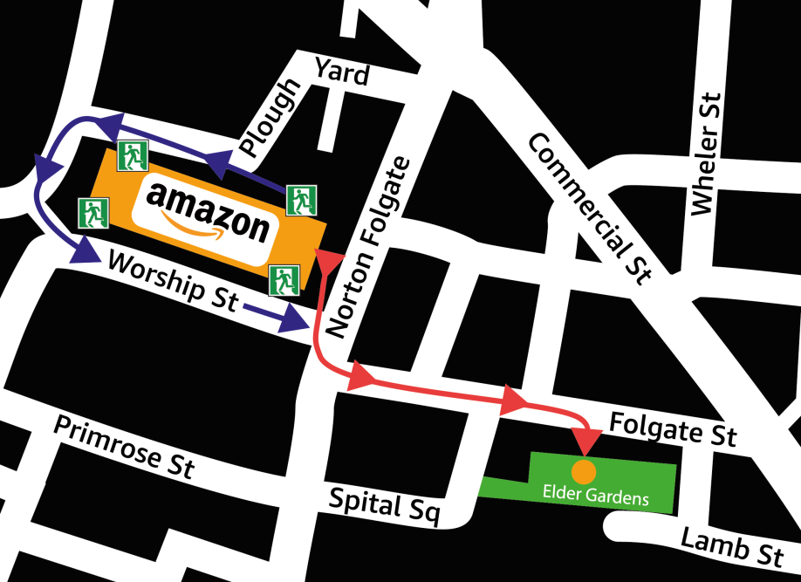
Exits
Muster point
Main route
Alternative route

