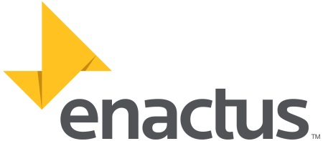

ENACTUS NOTTINGHAM CROWNED ENACTUS UK
NATIONAL CHAMPION, 2016
Date: 15th April 2016
Release Time: Immediate

The top 35 Enactus teams from across the UK competed in the Enactus UK 2016 National Competition, at the Novotel, Hammersmith, London.

The dynamic, energy filled event brought together 800 university students, 60 academics, and over 400 senior business leaders. The Enactus teams competed for the title of Enactus UK National Champion through showcasing their community outreach projects to business executives serving as judges. The students were evaluated by how successfully they applied business concepts and an entrepreneurial approach to improve the quality of life of those in need. The final round judging panel comprised 70 senior business leaders from blue chip companies including Lord Michael Hasting CBE, Global Head of Corporate Citizenship, KPMG International and Stuart Mitchell, Group Chief Executive SIG plc.

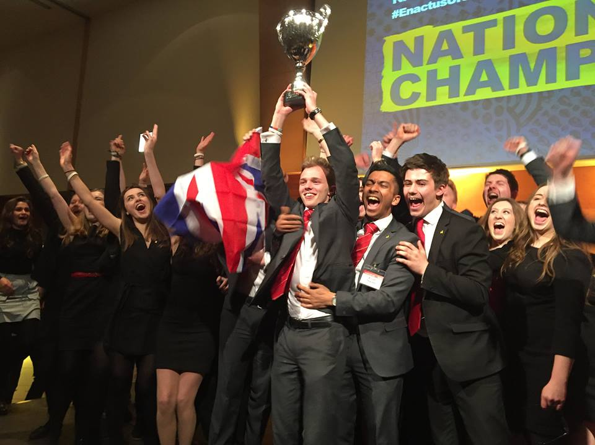

Enactus Nottingham won the competition after showcasing two of their inspirational social enterprises. The first, Re-covered, employs people in need to refurbish unwanted furniture which is then sold on to residents in housing associations. The second, Aquor, uses their own water filter design to provide clean water to thousands in Cameroon. Enactus Nottingham will go on to represent Enactus UK in the Enactus World Cup 2016 and will compete against 35 other countries in Toronto, Canada in September. Last year’s UK champion, from the University of Southampton is the reigning World Champion after their barnstorming success in Johannesburg, so the UK are hoping for success again this year. London has been selected to host the Enactus World Cup in October 2017 for the first time since 2004 and the Enactus UK team are already organising the event and are excited to welcome students, university staff and business leaders from all over the world. Vince Robson, faculty advisor for Enactus Durham said “The past two days have been fantastic. We really had a superb time, our team grew in confidence with every round and were ecstatic to reach the final five. It is now with increase excitement that we look ahead – we’ve set the bar now and are looking forward to the next 12 months.”

This 2-day action-packed event consisted of more than the competition; it included a Career Fair and a Project Fair in which the students showcased their flagship social projects to participants. The student and business leaders also took part in round table discussions about responsible leadership and harnessing talents for future success. Stuart West of the Ford Motor Company said of the event “Having attended 2 Enactus UK Finals, I am very impressed with the calibre of the students and the quality of the projects undertaken. This year was especially pleasing to be able to bring the Ford C3 Awards sponsored by the Ford Motor Company Fund to the Finals and that one of our winners, Nottingham University, were also crowned as the National UK Champions. Congratulations to Nottingham University and to all of the students who participated.”

Andrew Bacon, CEO Enactus UK was delighted with the success of the event - “Congratulations to Nottingham and all of our 56 teams who delivered so much more through their projects this year. It was very pleasing to see the growth in numbers and diversity of students participating in the programme this year. Every stage of the competition was more competitive this year and that is down to the hard work of all involved in the programme be they the team members, their business advisers and the support from their universities. We look forward to the World Cup in Toronto in September and to a stronger and bigger programme in 2017.”

End

Notes for the Editors
- Founded in 1975, Enactus is an international community of student, academic and business leaders committed to using the power of entrepreneurial action to transform lives and shape a better, more sustainable world.
- Enactus UK was founded in 2001 and now operates in 56 universities, with more than 3000 active students.
- For more information about Enactus, please visit:
www.enactus.org and www.enactusuk.org
- Last year, 3000 Enactus students from across the UK volunteered more than 187,000 hours to create and implement some 250 projects that improved the lives of 4800 people.
- Enactus projects use innovative and entrepreneurial solutions to tackle a wide range of social needs including: empowering diverse beneficiaries such as the unemployed, homeless, struggling businesses, immigrants and ex-offenders. They also harness the expertise of engineering students to tackle issues such as sanitation, irrigation and disease oversees. These experiences not only transform lives, but give students the opportunity to step out of the classroom and develop skills firsthand and the perspective that is essential to leadership in an ever-more complicated and challenging world.
- For project examples, please visit: www.enactusuk.org/what-we-do/project-stories
- In the UK, Enactus actively engages business and academic volunteers [over 580 business, 120 university and 120 alumni volunteers] who provide know-how in a framework that encourages the students to be innovative, creative, and to take advantage of the unique resources and opportunities at their university.

For further information contact:
Rosie Connolly, Operations Director, Enactus UK
Email: rconnolly@enactus.org Tel: 07538379620

Follow us on Twitter: www.Twitter.com/EnactusUK
Follow us on Facebook: www.Facebook.com/EnactusUK

